Programming in Java

Assignment

By

Krzysztof Dziurawiec

HNC Student

Content:

1. Project proposal
2. Project plan
3. Project design:
   1. Record structure design
   2. User interface components design
   3. Data flow diagram
   4. Entity relationship diagram
   5. Class diagram
4. System testing
   1. Test schedule and results
   2. Report on test scheduled for Image Viewer application
5. System evaluation

**Project Proposal**

Proposed project is a development of software which would store in file(s) images with their associated text and be able to retrieve that information from file(s) which, would be than displayed in picture viewer. The software should have GUI windows user interface. User should be able to navigate between stored pictures and be able to add description to them. As an addition should be included dropdown box with picture list selection for quick access.

For development of proposed software I will use Java programming language which support object orientated techniques needed for this project. I would include following components: Swing components to create GUI environment, Layout Managers which allow displaying all components in correct manner, FileWriter Class which provide file writing function and FileReader Class which provide file reading functions.

As assistance with development of proposed project, error handling and testing I will use Eclipse integrated development environment (IDE) software for Java.

**Project Plan**

|  |  |  |  |
| --- | --- | --- | --- |
| Task Name | Task Description | Start Date | Finish Date |
| Start of project | Start of project | 08/06/15 | 08/06/15 |
| Project proposal | Producing project proposal | 08/06/15 | 08/06/15 |
| Project plan | Producing project plan | 09/06/15 | 09/06/15 |
| Designing stage | Designing record structure, user interface components for maintaining, retrieving and displaying selected information | 10/06/15 | 11/06/15 |
| Implementing design produce | Creating working software by using Java components | 12/06/15 | 23/06/15 |
| Testing stage | Testing all function of the software and fixing errors | 24/06/15 | 24/06/15 |
| Evaluation and Hand over | Producing evaluation of created software and recommendation list of future improvements | 25/06/15 | 26/06/15 |

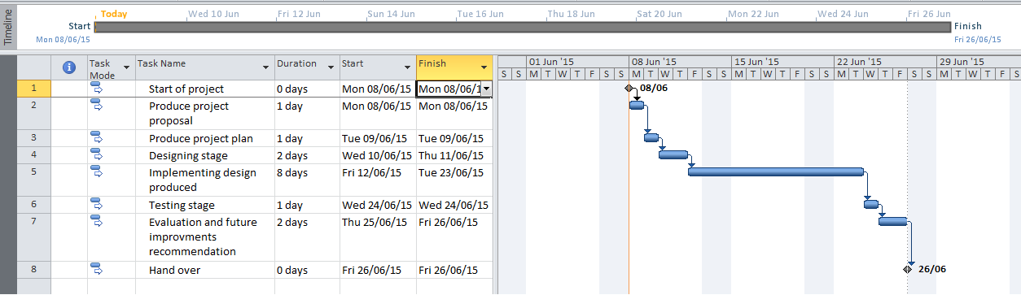

**Project Design**

* **Record structure design**

The record structure of proposed project will be held in JAVA folder. Inside this folder would be three folders: Images, Text, JavaRun.

Images folder would store all images which would be retrieved into the image viewer as an image files.

Text folder would store all description associated with corresponding picture as a text files.

JavaRun folder would store all java files which are needed to run software.

|  |  |
| --- | --- |
| **File** | **Description** |
| Images | Folder holding images files |
| image01 | Application create class for this file and displays it |
| image02 | Application create class for this file and displays it |
| image03 | Application create class for this file and displays it |
| image04 | Application create class for this file and displays it |
| image05 | Application create class for this file and displays it |
| image06 | Application create class for this file and displays it |
| image07 | Application create class for this file and displays it |
| image08 | Application create class for this file and displays it |
| image09 | Application create class for this file and displays it |
| Image10 | Application create class for this file and displays it |
| Text | Folder holding text files with images descriptions |
| text01 | File hold text description of associated image |
| text02 | File hold text description of associated image |
| text03 | File hold text description of associated image |
| text04 | File hold text description of associated image |
| text05 | File hold text description of associated image |
| text06 | File hold text description of associated image |
| text07 | File hold text description of associated image |
| text08 | File hold text description of associated image |
| text09 | File hold text description of associated image |
| text10 | File hold text description of associated image |
|  |  |
| run.exe | File opening application |
| about.txt | Text file holding help and support information |
| readme.txt | Text file holding how to install and run program information |

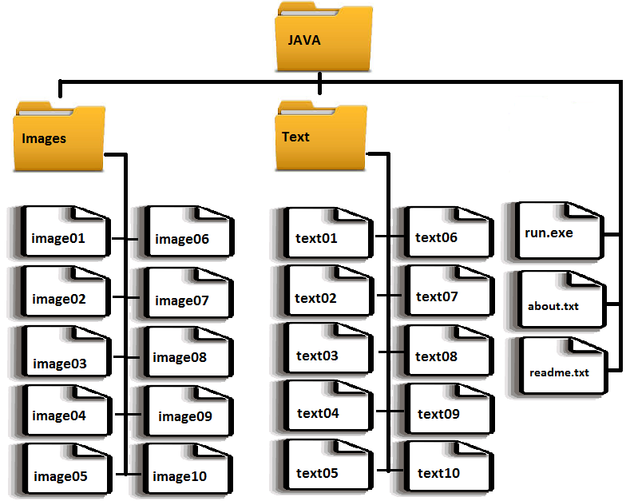

* **User interface components design**

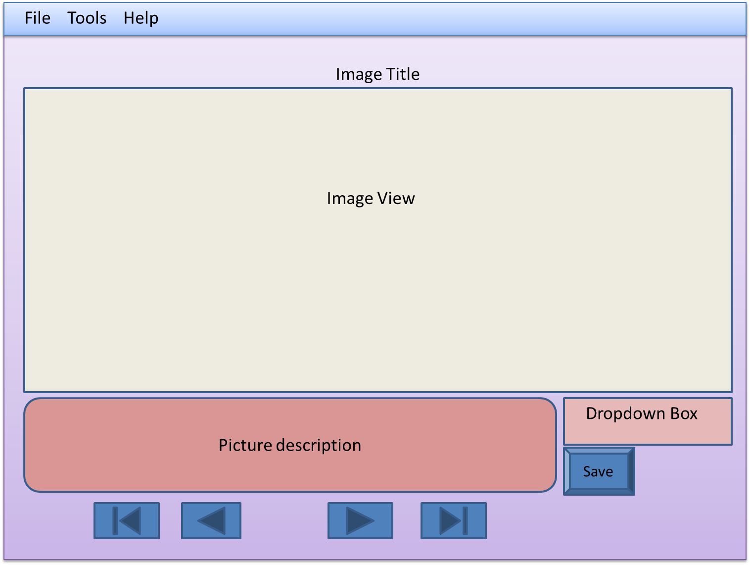

* JFrame window in size 700 by 680
* Menu bar set at the top of JFrame window include menu options. “File” menu consist “Open in Paint” option, “Save” option and “Close” option. “Tools” menu include: “Font Colour” option which allows changing font colour in text area, “Look and Feel” submenu consisting two options for look of the application: “Nimbus” set as default and “Metal” as an optional. “Help” menu includes “About” option which consist text regarding use of application and Support details.
* Image title which is stored in text file in first line.
* Image view is a JLabel area in size 640 by 360. Image view area is designed to display chosen image from images folder
* Picture description is a editable JText Field located below image view. It consist text related to displayed image which is stored in text file in text folder.
* Dropdown box allows searching for specific text and picture.
* Save is a JButton which allows saving changes made to the text in picture description area.
* Navigation buttons under the picture description area are Jbuttons which are helping with navigation between pictures, they function after pressing them from left are: go back to the first picture, go to previous picture, go to next picture and go back to the last picture.
* **Data Flow Diagram**

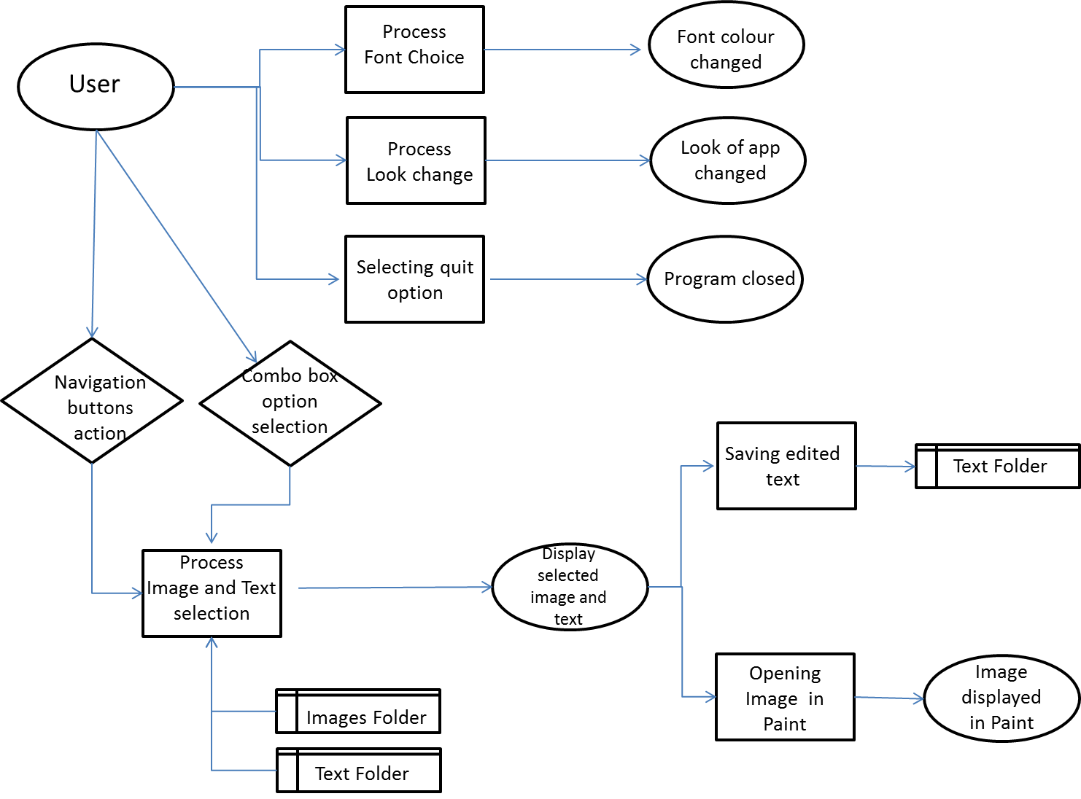

* **Entity relationship diagram**

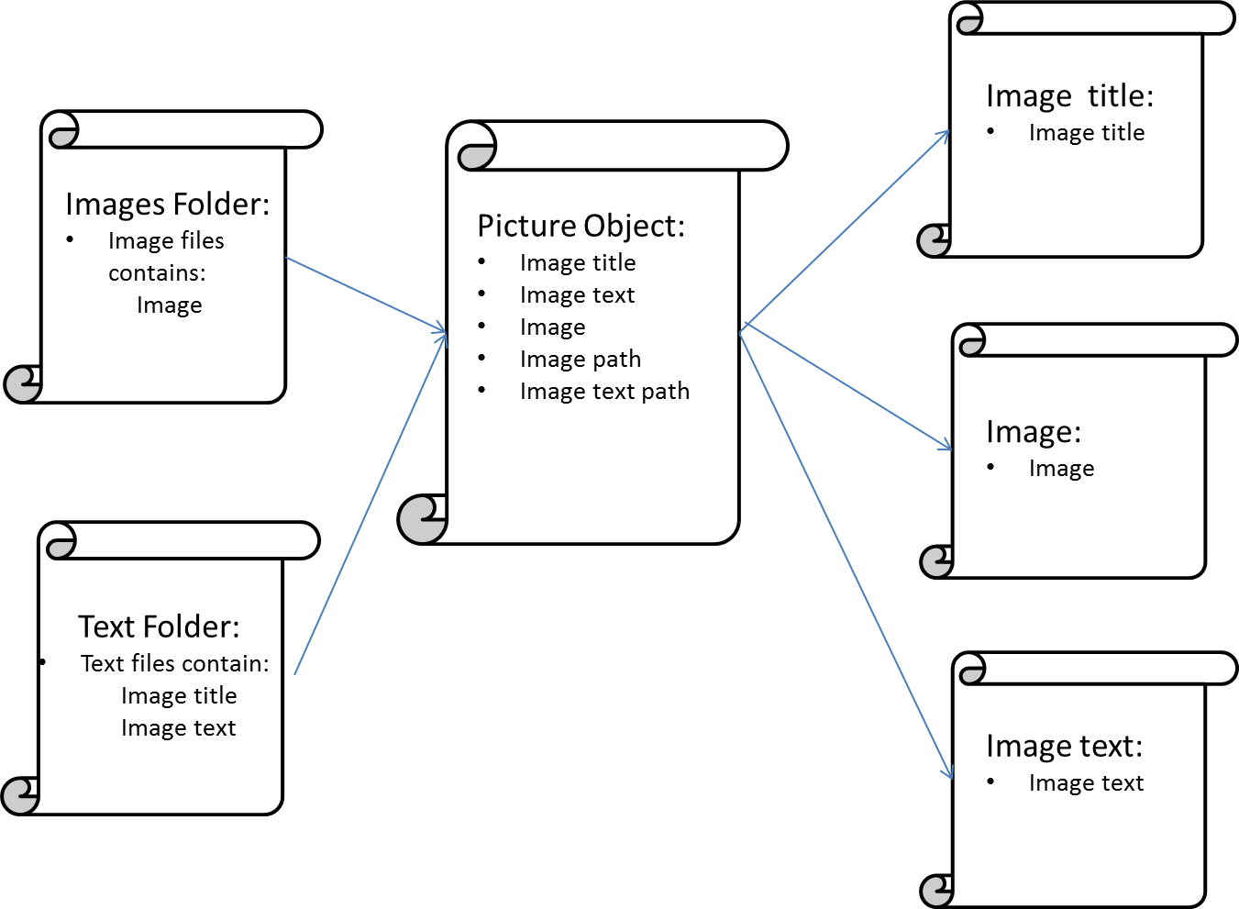

* **Class diagram**

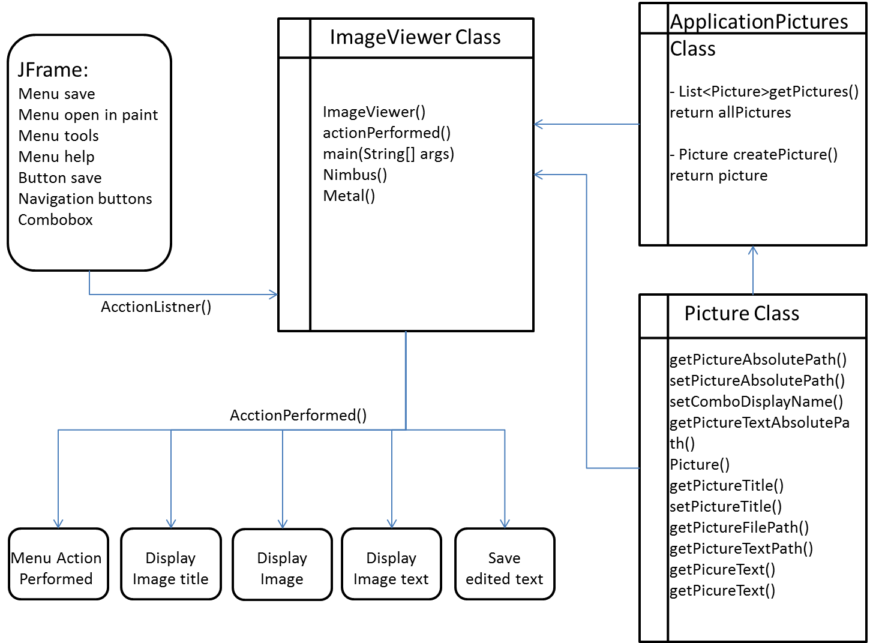

**System testing**

1. Test schedule and results

|  |  |  |  |  |  |
| --- | --- | --- | --- | --- | --- |
|  | **Test action** | **Expected result** | **Actual result** | **OK** | **Action** |
| 1 | Opening application | Application open in centre of the screen with displayed first image, text and welcome screen |  | Yes |  |
| 2 | Display welcome title | Welcome Title displayed for 3 seconds and change to bike title | Welcome Title displayed for 3 seconds and change to bike title | Yes |  |
| 3 | Closing application by Close menu option | Message window ask if you want to quit, after clicking yes application terminate. |  | Yes |  |
| 4 | Closing application using Ctrl x shortcut | Message window display, asking if you want to quit, after clicking yes application terminate. | Message window display, asking if you want to quit, after clicking yes application terminate. | Yes |  |
| 5 | Clicking Next button | Next picture from the folder should be displayed with correct text and title |  | Yes |  |
| 6 | Clicking Next button when last picture in folder is displayed | Message window should announce that this is last picture in the folder |  | Yes |  |
| 7 | Clicking Back button | Previous picture is displayed with correct text and title |  | Yes |  |
| 8 | Clicking Back button when first picture is displayed | Message window should announce that this is first picture in the folder |  | Yes |  |
| 9 | Clicking Last button | Displays last image with text and title in the folder | Displays last image with text and title in the folder | Yes |  |
| 10 | Clicking First button | Displays first image with text and title in the folder | Displays first image with text and title in the folder | Yes |  |
| 11 | Selecting test4 in combo box from the list | Display text4 with image4 and right title |  | Yes |  |
| 12 | Selecting test9 in combo box from the list | Display text9 with image4 and right title |  | Yes |  |
| 13 | Displaying selected image with right text and title | Image5 displayed with text5 and title: KTM RC8R | Image5 displayed with text5 and title: KTM RC8R | Yes |  |
| 14 | Displaying selected image with right text and title | Image8 displayed with text8 and title: BMW K1300R | Image8 displayed with text8 and title: BMW K1300R | Yes |  |
| 15 | Displaying next images in correct order after next selection | After image8 next image displayed is image9 | After image8 next image displayed is image9 | Yes |  |
| 16 | Editing text | After clicking on the text field cursor starts blinking and text can be modified |  | Yes |  |
| 17 | Saving text by Save button | File directory should open in current directory and after choice of file and clicking on Save button changes would be saved. |  | Yes |  |
| 18 | Saving text by Save menu option | File directory opens in current directory and after choice of file and clicking on Save button changes would be saved. | File directory opens in current directory and after choice of file and clicking on Save button changes would be saved. | Yes |  |
| 19 | While using Save option, opening directory in current program location | Directory should be open in text folder in current program location | Directory is set as default for different location | No | Added method to getCurrentProgram FullPath to the text folder after which expected result is achieved |
| 20 | Opening picture in Paint application | After clicking on Open in paint option in menu File current image is open in Paint |  | Yes |  |
| 21 | Using Font Colour option | Font colour changed to pink |  | Yes |  |
| 22 | Choosing Look and Feel option Metal | Application look is changed to Metal theme | Application look is changed to Metal theme | Yes |  |
| 23 | Choosing Look and Feel option Nimbus | Application look is changed to Nimbus theme | Application look is changed to Nimbus theme | Yes |  |
| 24 | Opening About option in Help menu | Notepad opens with about.txt file | Notepad opens with about.txt file | Yes |  |
| 25 | Showing help clues while hovering over objects | Showing help message tooltip over text area |  | Yes |  |
| 26 | Adding more images with related text to the folder | Displaying new pictures after clicking next button | Added images are not showing becouse the loop for list is limited to 10 images | No | For loop need to be changed to new number of images every time, as future improvement recommend to adjust the loop structure so any number of elements can be displayed |

1. Report on test scheduled for Image Viewer application

After completed test schedule that covers all of the program functionality I found following:

Regarding to tests 1-4, application is opening after double clicking on run.jar file. Application opens in the middle of the screen with all GUI elements displayed in designed places. First image in the folder is displayed correctly with related text. Welcome title is displayed for three seconds after which is changed automatically to current image title.

Closing application is working properly by using Close option or keyboard shortcut. Warning message is displayed and user is asked for close choice confirmation.

Test 5 - 10 and test 15: shows navigation buttons functionality and that application is reading correct files from correct folders in right sequence.

Next button is working correctly and clicking it, change image to the next image in the right order. Back button is working correctly and change current image to previous in the right order. As an exception handling method, message boxes are displayed when user reached last or first image.

First and Last buttons are working correctly by going accordingly to the first image in the folder and last image in the folder.

Tests 11 – 12 are showing correct display of combo box selected choices.

Tests 13 – 14 are proving that to every image selected correct text and title is displayed.

In tests 16 to 19 editing and saving option are tested. Selected text can be edited and saved into specified file in directory. Directory was not displaying current program path, so I modified code to open directory in the current program location which solved the issue. Even moving program to new location will still open correct path to the folder holding text files.

Test 20 shows that Open in Paint option is working correctly and selected image is open in Paint application.

Tests 21 – 23 are showing that additional features to change font colour or application theme are working correctly.

Test 24 shows that about.txt which holds help and support information is opening in notepad.

Test 25 is showing that tooltip help information are displayed correctly while hovering over objects with mouse.

Test 26 checks if program is scalable. Currently program displays 10 images, more images can be added for displaying but currently adjustment needs to be made in the List of images loop but this is not user friendly solution.

**System evaluation**

In conclusion, all tested features included in Image Viewer application are working correctly. Data is stored accurately in designed files: text(x).txt and images(x).jpg. Program is reading data from the file accurately and displays it in structured GUI environment. All elements are displayed in right place and correct order.

All menu options are working properly and correct functions are open after clicking selected option. All buttons are working properly and assigned functionality is working correctly. External program Paint and Notepad are opening as an option from main program.

Having options to change application look theme and font colour it provide option to personalize application accordingly to the user taste and make it more personal. Unfortunately the settings selected by user are lost after application is closed, so I would suggest as an future improvement to save changed settings by overriding current default settings which allows to reopen application with user preferred theme.

Handling exceptions are working accurate, by informing user about reaching beginning or end of the folder. “Try catch” exceptions implemented in the code are working correctly while opening text files or image files.

Current version of application is very rigid, it is possible to scale program by adding new images and texts but currently it is not user friendly. As an improvement, I would suggest creating a separate option for adding new images and text to the current Array List which would be more user friendly then current option which need adjusting the For loop counter “i” to the new number of files.